Fiche de révision Project Management
Process groups :
Each phase can be a project. Each project requires processes.
- Initiating
- Planning
- Executing
- Monitoring and Controlling: lasts during whole project
- Closing
Project areas:
Based on the PMBOK® Guide, there are 10 knowledge areas:
1. Project Integration Management
2. Project Scope Management
3. Project Time Management
4. Project Cost Management
5. Project Quality Management
6. Project Human Resource Management
7. Project Communication Management
8. Project Risk Management
9. Project Procurement Management
10.Project Stakeholder Management
All knowledge areas are controlled.
Processes:
Pas facile à résumer
Summarizing slides:
Critical path:
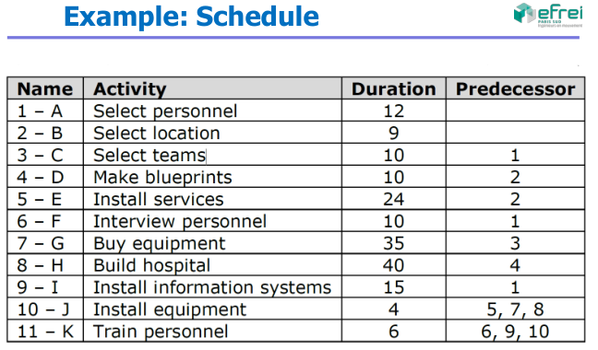
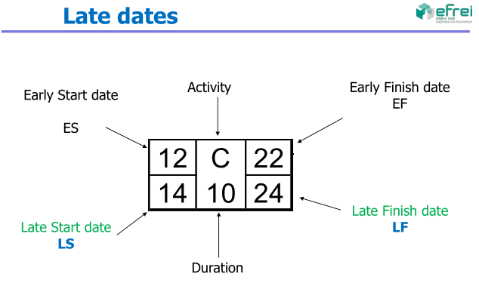
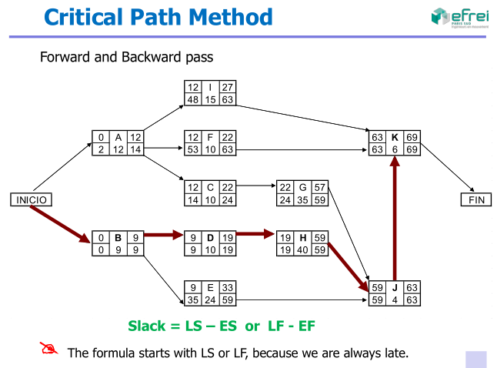
Earned value:
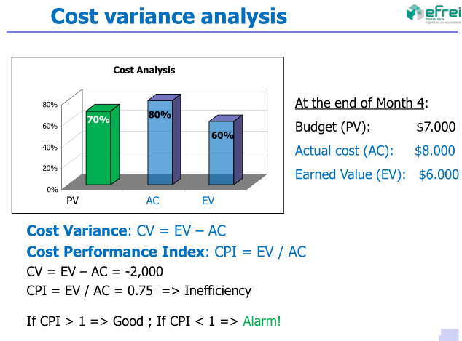
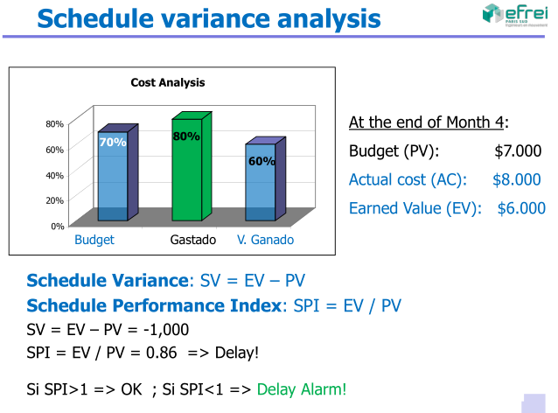
Estimation:
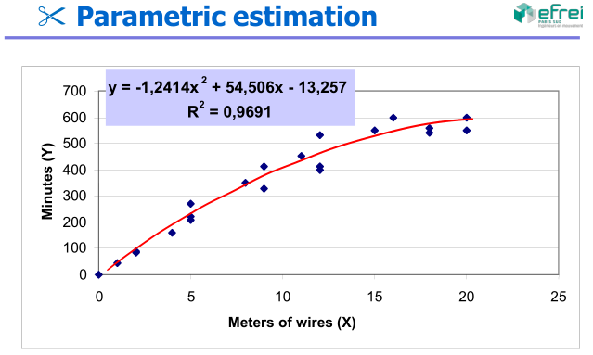
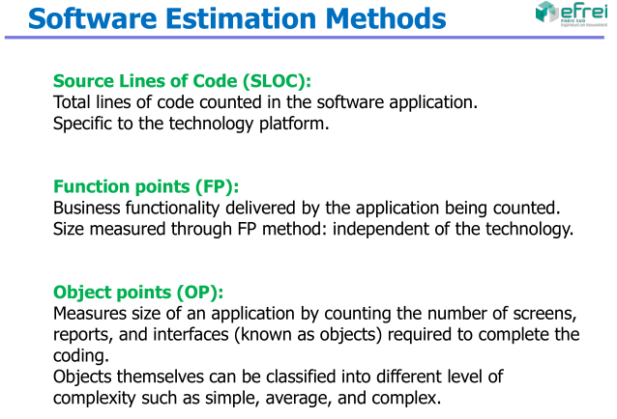
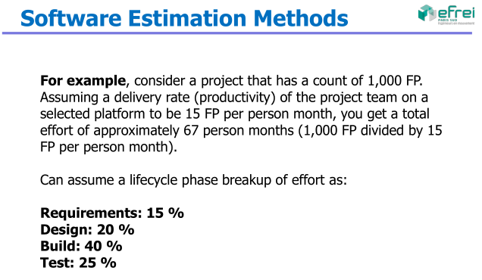
Change request:
??
Quality tools:
1. Cause-and-effect diagram: what causes problems
2. Flowcharts: what is done
3. Check sheets: recollect and organize the data
4. Histograms: graphical view of the variations
5. Pareto chart: problem ranking
6. Control charts: variations control
7. Scatter diagrams: relation between variables
risk strategies
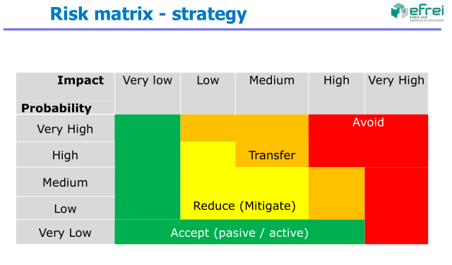
stakeholder strategies
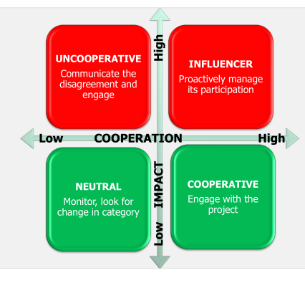
conflict resolution
Causes: schedules, change of priorities, and lack of
resources, etc.
- Conflict => ≠ opinions => more creativity => Good !
- Well manage => more productivity
- Address them early and in private
- Use a direct and constructive approach
- Last option => disciplinary actions
What is the main source of conflict in projects ?
A. Schedule
B. Priorities
C. Costs
D. Personalities
Answer:
1º Schedule, 2º Priorities, 3º Resources,
4º Technicalities, 5º Administrative processes, 6º Costs
7º LAST – Personality
What is the most convenient way of conflict resolution?
A. Withdraw / Avoid: step away from conflict
B. Smooth / Accommodate: emphasize on agreement
areas rather than on differences
C. Compromise / Reconcile: each side should let go of something
D. Force / Direct: impose one position at the expense of others
E. Collaborate: seek different opinions to find commitmentand consensus
Answer:
1º Collaborate = Conflict resolution (win-win)
2º Compromise or reconcile (lose-lose)
The worst: Force or withdraw
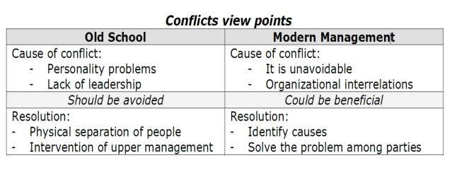
Conflict management STEPS:
1. Identify the problem root cause
2. Analyze the problem
3. Identify alternative solutions
4. Implement a decision
5. Validate if that decision solved the problem
human resources leadership
Types of power:
Formal – Hierarchical position in the company
Rewards – Authority to manage recompenses
Penalty – Authority to manage punishment
Expert – Based on knowledge and formation
Referred – referred by a superior
software development
life cycle stages and testing
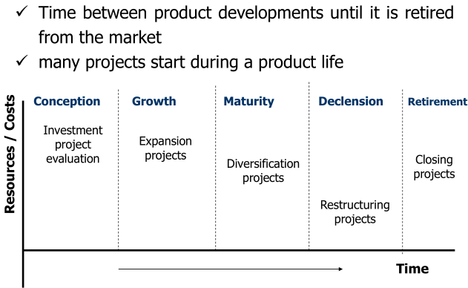
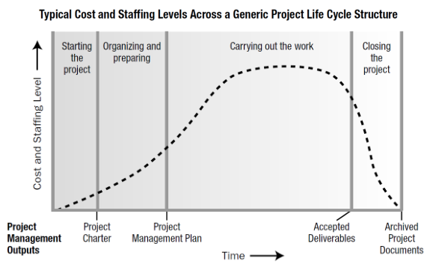
provider selection in procurements

